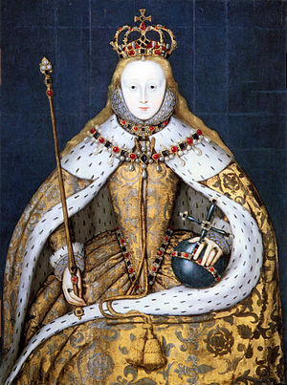
Name: Elizabeth I.
Dates of reign:

Friends:

Likes:

Dislikes:

Achievements:

Achievements:

Favourite images:

